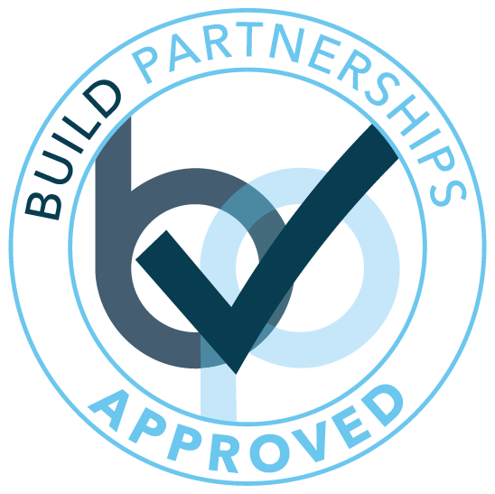

**Issue Date:**

**Expiry Date:**

Certificate

of Compliance

***Harry K&H Construction Co. Limited***

17/12/2019

16/12/2020

This certificate of compliance confirms the above Company has been pre-qualified, approved and is now a partnered contractor of Build Partnerships Group

`

**Brad Sussman**

Managing Director

**Tracy Burrell**

Compliance Manager

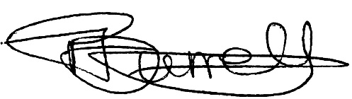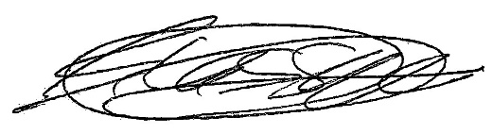

Suite 1, Days Farm, Days Lane, Brentwood, Essex, CM15 9SL

www.buildpartnerships.com | info@buildpartnerships.com | 01277 320 674

© 2020 Build Partnerships Limited